**Advance Excel Assignment 21**

1. Write a VBA code to enter your name in A1 Cell using Input Box and once you enter the name display a message box that says the name has been entered.

Ans. 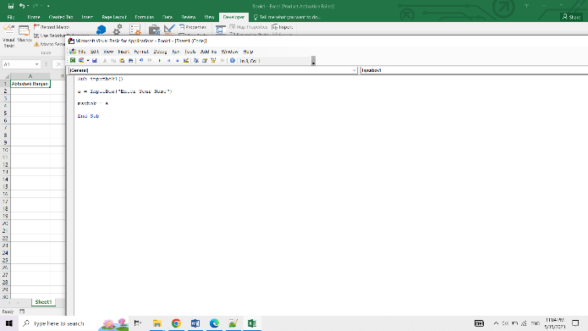

1. What are Userforms? Why are they used? How to fill a list box using for loop.

Ans. UserForms provide a way to interact with users, display information, and collect input from them. They are used to create customized input forms, data entry screens, interactive dashboards, and more.

Here are some key reasons for using UserForms:

* Enhanced User Experience: UserForms provide a more intuitive and user-friendly way for users to interact with our VBA applications. They can display relevant information, provide input controls such as text boxes and buttons, and offer a structured and visually appealing interface.
* Data Entry and Validation: UserForms are commonly used to create data entry forms where users can input data in a structured manner. We can include validation checks to ensure data accuracy and enforce business rules.
* Customized Functionality: UserForms allow us to create custom functionalities tailored to our specific needs. We can combine various controls, such as text boxes, checkboxes, option buttons, list boxes, etc., to build complex and interactive interfaces.
* Data Display and Reporting: UserForms can be used to display data in a more organized and visually appealing way. We can present data in tables, charts, or other formats, providing users with a comprehensive view of the information.

1. What is an array? Write a VBA code to enter students and their marks from the below table.

Ans. An array is a range or group of values that are stored together as a single entity. It allows us to work with multiple data values simultaneously and perform calculations or operations on them.

Arrays in Excel can be one-dimensional (a single row or column of values) or multi-dimensional (multiple rows and columns of values).

* Array Formulas: Excel supports array formulas, which are formulas that can perform calculations on multiple values at once. Array formulas are enclosed in curly braces {} and are entered by pressing Ctrl + Shift + Enter after typing the formula. They can perform calculations across multiple cells and return multiple results.
* Array Functions: Excel includes built-in functions that can work with arrays directly. These functions are designed to handle arrays as arguments and return array results. Some examples of array functions are SUM, AVERAGE, MIN, MAX, TRANSPOSE, etc.
* Dynamic Arrays: Starting from Excel 365, dynamic arrays were introduced, allowing formulas to automatically spill results into adjacent cells. With dynamic arrays, we can enter a formula in a single cell and have it automatically populate the neighboring cells with the corresponding results.
* Array Constants: Array constants are static arrays that are entered directly into a formula or a range of cells. They are enclosed in curly braces {} and contain multiple values separated by commas or semicolons. Array constants allow us to provide multiple inputs or criteria to a formula in a concise manner.
* Array Manipulation: Excel provides various functions and features to manipulate arrays, such as sorting, filtering, transposing, and joining arrays. These operations allow us to rearrange, filter, or combine array elements to obtain the desired results.
* Array Functions in VBA: In VBA (Visual Basic for Applications), we can work with arrays directly to perform calculations or store data. VBA supports one-dimensional and multi-dimensional arrays, allowing us to handle large datasets efficiently.

1. . Use the following data to create a pie chart using VBA code. Use Font - ‘Times new Roman’, Size -14, Bold, Title - Piechart’ and you are per to use colours as per your taste.

Ans. 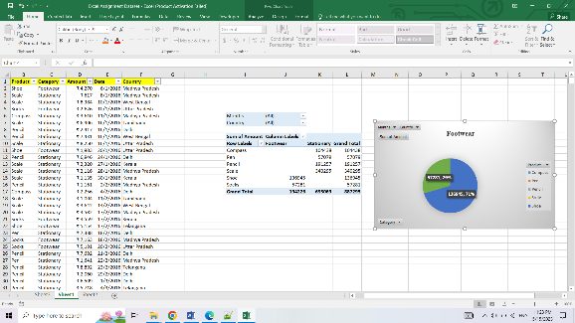

1. Check the dataset in the link given below and create a pivot table using VBA showing the sales for the year from stationary category.

Ans.

|  |  |  |  |
| --- | --- | --- | --- |
| Months | (All) |  |  |
| Country | (All) |  |  |
|  |  |  |  |
| **Sum of Amount** | **Column Labels** |  |  |
| **Row Labels** | **Footwear** | **Stationary** | **Grand Total** |
| Compass |  | 104438 | 104438 |
| Pen |  | 57079 | 57079 |
| Pencil |  | 191257 | 191257 |
| Scale |  | 340295 | 340295 |
| Shoe | 136945 |  | 136945 |
| Socks | 57281 |  | 57281 |
| **Grand Total** | **194226** | **693069** | **887295** |

1. . Write step by step procedure to protect your workbook using a password.

Ans. To protect our workbook using a password in Excel, follow these step-by-step instructions:

* Open our Excel workbook.
* Click on the "File" tab in the ribbon at the top left corner of the Excel window.
* In the left-hand sidebar, click on "Protect Workbook" under the "Info" section. This will open a drop-down menu.
* From the drop-down menu, select "Encrypt with Password." This will open the "Encrypt Document" dialog box.
* In the "Password" field, enter the password we want to use to protect our workbook. Make sure to choose a strong and secure password.
* Click "OK" to apply the password and close the dialog box. Excel will prompt we to confirm the password by re-entering it.
* Re-enter the password in the "Reenter password to open this workbook" field and click "OK."
* Save our workbook by clicking on the "File" tab and selecting "Save" or pressing Ctrl + S.
* Close the workbook and reopen it to test the password protection.
* When we reopen the workbook, Excel will prompt we to enter the password. Enter the correct password, and if it matches, we will gain access to the workbook. If we enter the wrong password, we won't be able to open the workbook.